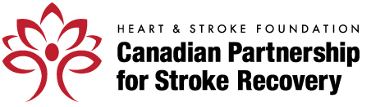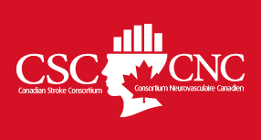

CaSTOR Fact Sheet:

What is CaSTOR?

CaSTOR stands for Canadian Stroke Trials for Optimized Results. It is a joint initiative of the Canadian Stroke Consortium and HSF Canadian Partnership for Stroke Recovery.

CaSTOR will develop and build a vibrant and productive Canadian stroke trial community that is world class in generating and applying new knowledge in stroke prevention, treatment and recovery.

CaSTOR’s aim is to:
- catalyze clinical trials (in Canada and with international partners) to address critical knowledge gaps in stroke prevention, treatment and recovery
- build and enhance capacity for research and care through education and mentoring
- accelerate and advance knowledge translation

What does CaSTOR mean for you?

For researchers:
- provides an opportunity to collaborate with clinical trialists across Canada and around the world through networked efforts;
- establishes, supports and improves Canadian clinical trial centres in acute stroke, prevention, rehabilitation and recovery;
- leverages funding from private and non-profit sources to create opportunities for pilot studies;
- develops national and international partnerships to tap into;
- creates a research strategy to address the full stroke continuum;
- strengthens leadership position of Canadian stroke trialists in the international community.

For the universities, health-care centres and funding agencies:
- strengthens the quality of Canadian stroke clinical trials research and makes it more competitive for external funding;
- builds Canada’s capacity in clinical research;
- improves training and mentoring programs;
- fosters creation of “across the stroke care continuum” network of stroke trials centres developed with a hub-and-spoke model; and,
- improves education, collaboration and communication among stroke trainees from all disciplines including neurology, physiatry, emergency medicine, geriatrics, and allied health.

For patients and families:
- develops new clinical approaches, tools and resources to improve deliver of care, prevent strokes and enhance recovery;
- engages people living with stroke and their care partners in the development of new initiatives; and,
- entrenches a patient-centred approach in all research activities.

To learn more about CaSTOR, please contact:

Farrell Leibovitch, M.Sc.
Director of Research and Training Programs
HSF Canadian Partnership for Stroke Recovery
647-801-0046
farrell@canadianstroke.ca

www.canadianstroke.ca: The Heart and Stroke Foundation Canadian Partnership for Stroke Recovery is a joint initiative of the Heart and Stroke Foundation and Canada’s leading stroke recovery research centres. Headquartered at the University of Ottawa, the Partnership is restoring lives through research.

www.strokeconsortium.ca: Canadian Stroke Consortium (CSC) is the nation's premiere neurologist network. It is an academic alliance committed to the pursuit of anti-stroke therapies by designing and/or conducting research projects and clinical trials. Many of our members are opinion leaders in Canadian and international stroke research and clinical practice. Together with the pharmaceutical industry, our combined efforts continue to support emerging trends in CNS therapeutic development.

